FIREMEN’S MUSEUM TOUR
NEW BERN NEWCOMERS’ CLUB
DAY TRIPS GROUP
420 BROAD ST., NEW BERN
JANUARY 20, 2021
10:00 A.M.
COST: $7.00 (pay at door)
Please RSVP to either Joanne* or Ellen*
There will also be a sign-up sheet at the Nov. 11 meeting
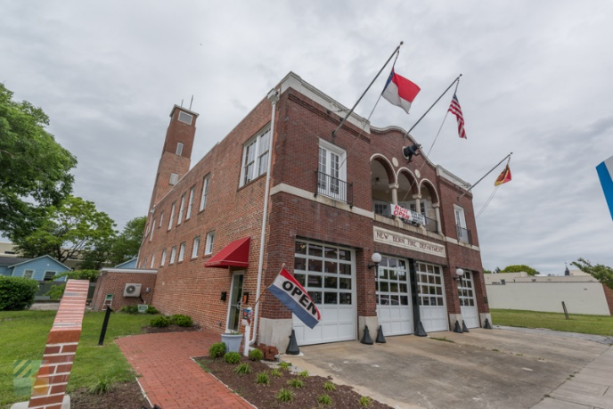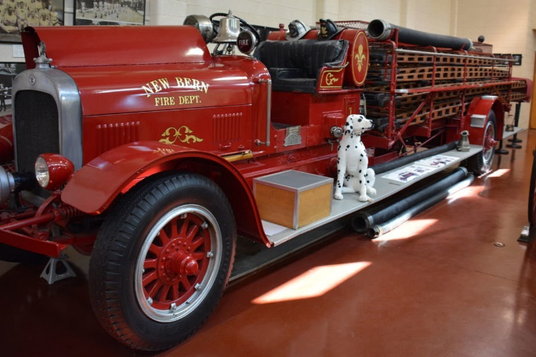
Local pride is inherent New Bern, and arguably there is no attraction where this is more apparent than the New Bern Firemen's Museum. Now housed in its completely renovated original 1928 station house, the museum has gained state-wide and national acclaim, (including a feature in North Carolina's renowned Our State magazine), for its restoration efforts, and more importantly, its nearly two centuries of fantastic stories and local history. Come celebrate a piece of New Bern history!
*Ellen Cioccio ecioccio123@gmail.com 443-253-8311
*Joanne Orluk joanneorluk@gmail.com 781-632-7687

