NEW BERN NEWCOMERS CLUB
SPICE BOUQUET DAY TRIP
TUESDAY, FEBRUARY 22, 2022
12:00 NOON – 2:30 P.M.
$25.00 PER PERSON (PRE-PAID)

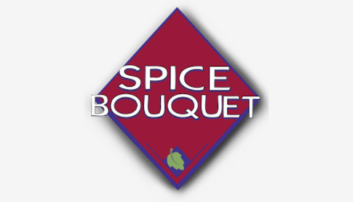

ADD A LITTLE SPICE TO YOUR LIFE AS WE VISIT SPICE BOUQUET IN KINSTON, NC.
THERE WILL BE A COOKING DEMONSTRATION CLASS USING SEVERAL DIFFERENT SPICES.
PARTICIPANTS WILL BE PROVIDED SAMPLES

FOLLOWING THE COOKING CLASS THERE WILL BE A COMPLETE SIT-DOWN LUNCH PREPARED BY THE SPICE BOUQUET CHEFS WHO WILL SHARE SOME SPICE TIPS WITH THE GROUP.
LUNCH INCLUDES SALAD, ENTRÉE, DESSERT AND SPICED (OR REGULAR) COFFEE AND TEA.
THIS IS A PRE-PAID EVENT. $25.00 PER PERSON.
PAYMENT MUST BE RECEIVED BY MONDAY, FEBRUARY 7.

------------------------------------------------------------------------------------------------------------------------------------------
REGISTRATION FORM
I/We will attend the day trip to Spice Bouquet on February 22, 2022.
NAME(S): ____________________________________________________________________________

PHONE: ______________________________ EMAIL: ______________________________________
AMOUNT ENCLOSED: $___________ (payment due no later than Monday, February 7)

Mail this form with payment to: Joanne Orluk, 420 Isabelle Street, New Bern, NC 28560
Make checks payable to Joanne Orluk and write “NBNC Spice” in the memo section.
You may also pay with VENMO (@Joanne-Orluk). If paying by VENMO, please send me an email letting me know that you would like to attend and that you are paying by VENMO. I will confirm that I received your VENMO payment.
Any questions, please contact: Joanne Orluk, 781-632-7687, joanneorluk@gmail.com OR
Ellen Cioccio, 443-253-8311, ecioccio123@gmail.com

