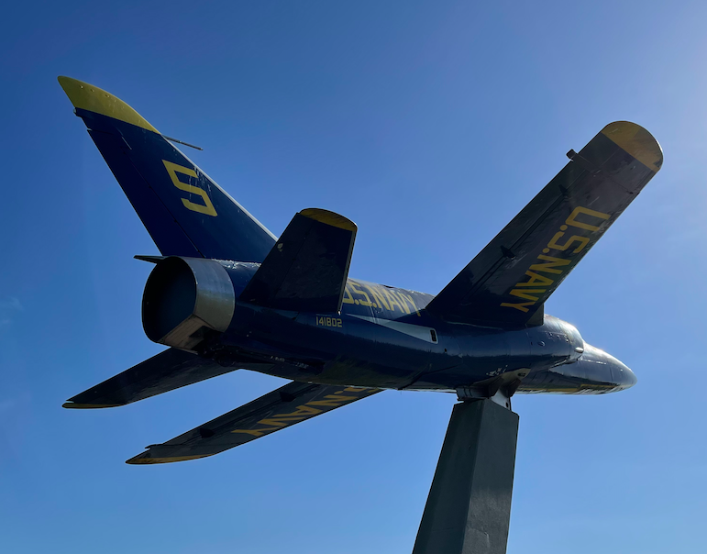

NEWCOMERS CLUB OF NEW BERN

**PHOTO WALK**

Tuesday, Jan. 31st,

Lawson Creek Park

In New Bern,

4 p.m.

**All current Newcomers Club members are invited to our January 2023 photo walk, beginning at 4:00 p.m., Tuesday Jan. 31, at Lawson Creek Park, to photograph nature and some great views of the river and of the historic downtown area of New Bern.**

This activity is lead by club member Rob Paine, a retired professional photographer.

The January Photo Walk will take place Tuesday, Jan. 31, from 4:00 p.m.. to roughly 5:30 p.m. We will meet at the Jack’s Island area of the park, which you can drive to by following the main park road past the Marina area.

This group is open to all skills levels and cameras. Questions? Email Rob at robertwpaine@gmail.com. If event is cancelled due to bad weather, I will email everyone that I have emails for. If you plan on going, an RSVP to [robertwpaine@gmail.com](mailto:robertwpaine@gmail.com) is requested but not required.

For more info on Lawson Creek Park, please visit <https://visitnewbern.com/lawson-creek-park-details/>. The park is located at 1309 Country Club Rd, New Bern. It is the park with the Blue Angel jet that you can see from Route 70.

We hope to see you January 31st.