Spring Has Sprung!
March Newcomers Club Local Day Trip Event
Presentation on New Bern-Friendly Landscaping and Garden Options
Pinecone Home and Garden Center
Saturday, 25 March 2023
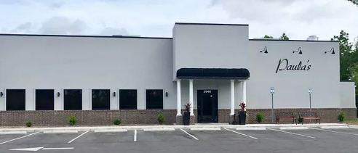
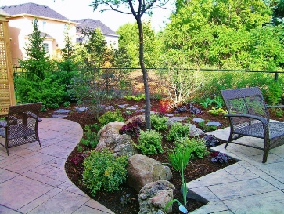

Recently relocated to New Bern and rented, bought, or built a house needing some landscaping TLC?! Join your fellow Newcomers Day Trippers at a presentation on lawn and garden flowers, shrubs, trees, and even veggies that are New Bern-area friendly. Wendy Graveman of Pinecone Home & Garden Center will offer tips to turn brown thumbs green whether you are planting plots or pots. She will be offering advice on landscaping with native species that should thrive in our coastal environment and answer any questions you may have from pest control to encouraging birds and butterflies to visit your yard! Light refreshments will be on hand. If you desire a more substantial dining experience, we can retire afterwards (@5:30) to nearby Paula's Pizza & Italian Restaurant for dinner.

DATE: Saturday, 25 March 2023
TIME: Presentation: 3:30 PM – 5:00 PM, Dinner 5:30 PM - ?
COST: None; dinner optional, payable at restaurant
PINECONE LOCATION: 4136 Dr. M L King Jr. Blvd, New Bern
PAULA’s LOCATION: 3946 Dr. M L King Jr. Blvd, New Bern

Please RSVP your interests for the Presentation and/or Dinner at Paula’s by 19 March to Andrea Britton, andybritton@verizon.net

